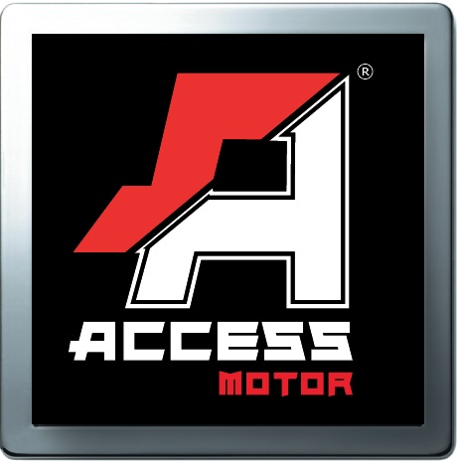
Access Motor CO., LTD
SPEED 300S Specification
Model | SP300 SPORT
Name | SPEED 300S
Engine
Type | Liquid-cooled, 4 stroke, 2 valve
Cylinder arrangement | Single cylinder, vertical
Displacement | 280.0 c.c.
Bore x Stroke (mm) | Ø74 x 65.2
Carburetor | Mikuni BSR33
Compression Ratio | 11
Ignition | C.D.I.
Starting System | Electric
Transmission | CVT with reverse , H/L Gear
Final drive | Chain/Oil-seal Chain 520
Chassis
Suspension / Front | Dual A-arm with 5 way preload-adjustable shocks
Suspension / Rear | Swing arm with preload adjustable shock
Brake / Front | R/L Disc brake
Brake / Rear | Disc Brake
Tire / Front | AT21 x 7- 10
Tire / Rear | AT20 x 11- 9
Dimensions
Overall length | 1825 mm
Overall width | 1230 mm
Overall height | 1140 mm
Seat height | 870 mm
Wheel base | 1270 mm
Ground clearance | 265mm
Claimed dry weight | 215 kg
Fuel capacity | 14.8 Liter
Oil capacity | 1.6 Lit.
Battery | GTX12-BS
Lubrication system | Wet sump, Oil Pump
Idle speed | 1600±100 rpm

