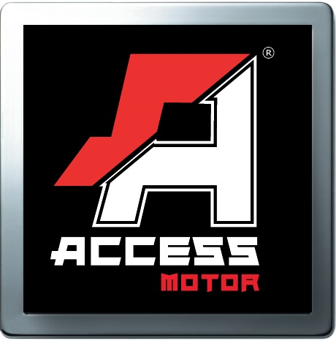
Access Motor CO., LTD
ST100LA-H00 Specification
Model | ST100LA
Name | STREAK 100
Engine
Type | Air cooling, two stroke
Cylinder arrangement | Single cylinder ,Level
Displacement | 95.6 c.c.
Bore x Stroke (mm) | Ø52 x 45
Carburetor | TK
Ignition | C.D.I.
Starting System | Electric, Kick
Transmission | CVT
Final drive | Chain/ 428H
Chassis
Suspension / Front | Oil Shock (Adjustable)
Suspension / Rear | Oil Shock (Adjustable)
Brake / Front | R/L Drum
Brake / Rear | Disc Brake
Tire / Front | 19*7-8
Tire / Rear | 18*9.5-8
Dimensions
Overall length | 1600 mm
Overall width | 980 mm
Overall height | 980 mm
Wheel base | 1100 mm
Claimed dry weight | 136 kg
Fuel capacity | 5 Liter
Oil capacity | 1.1 Lit.
Battery | CTX5L-BS
Idle speed | 1800±100 rpm

