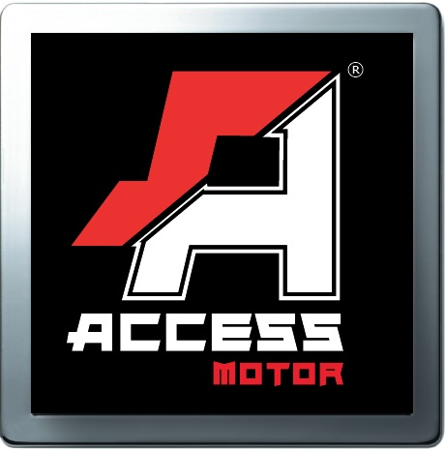
Access Motor CO., LTD
STREAK 100 Racing Specification
Model | ST100
Name | STREAK 100 Racing
Engine
Type | Liquid cooling, two stroke
Cylinder arrangement | Single cylinder ,Level
Displacement | 99.3 c.c.
Bore x Stroke (mm) | Ø53 x 45
Carburetor | Sun World PWK 28
Compression Ratio | 8.6
Ignition | C.D.I.
Starting System | Electric, Kick
Transmission | CVT without reverse
Final drive | Chain/ 428H
Chassis
Suspension / Front | Dual A-arm(44inch) with Gas Shock (Adjustable)
Suspension / Rear | Gas Shock (Adjustable)
Brake / Front | R/L Disc brake
Brake / Rear | Disc Brake
Tire / Front | RAZR1 19 x 6 - 10
Tire / Rear | K530F 18 x 9.5 - 8
Dimensions
Overall length | 1480 mm
Overall width | 1110 mm
Overall height | 980 mm
Seat height | 710 mm
Wheel base | 1010 mm
Ground clearance | 200 mm
Claimed dry weight | 124 kg
Fuel capacity | 5 Liter
Oil capacity | 1.1 Lit.
Battery | CTX5L-BS
Idle speed | 1800±100 rpm

